DESK PROCEDURE FOR CREATING & ACCESSING VAGRANT VIRTUAL MACHINES FROM A WINDOWS PLATFORM:

Requirements For This Solution:
1) Download and install Virtual Box:
2) Download and install Vagrant software
3) Download and install Cmder terminal software
4) Ensure your windows laptop \ computer is running powershell 3.0 or higher
5) Ensure the BIOS setting is enabled for Virtualization Technology - other BIOS names maybe VT-x and\or AMD-V settings.

PROCEDURE DONE ON MY PERSONAL WINDOWS LAPTOP:
1) download Virtual Box:
https://www.virtualbox.org/wiki/Downloads
2) install Virtual box:
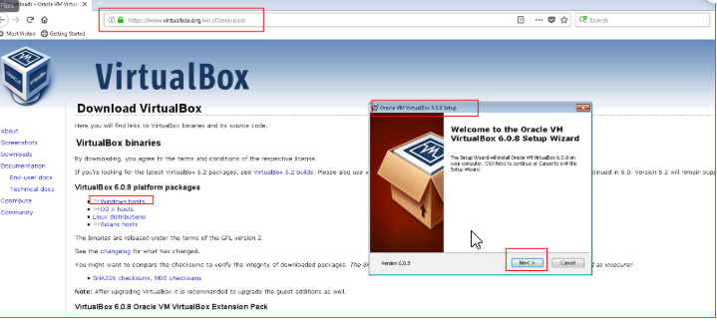

3) After the Virtual Box is installed, you can then download the Vagrant software:
https://www.vagrantup.com/downloads.html
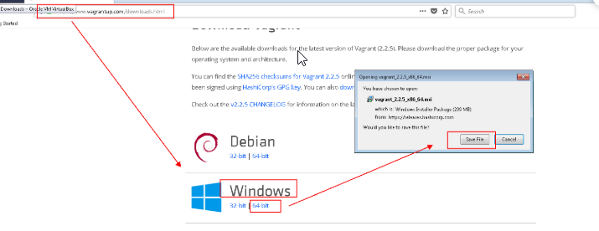

4) Next, download CMDER at the site below:
https://cmder.net/
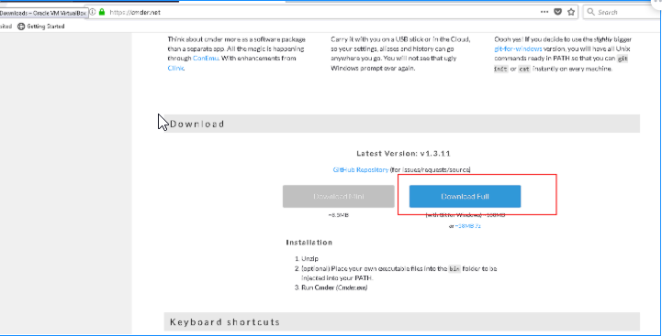

5) extract the downloaded file and then run the CMDER.EXE file as noted below. Launch the CMDER.EXE and click on the “Ignore and Continue” button when prompted.
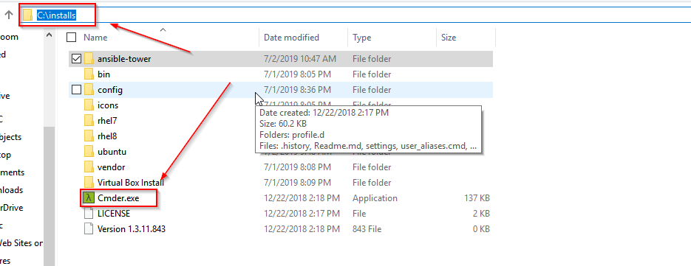

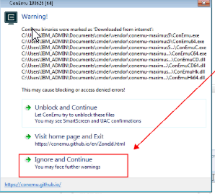

6) launch cmder and check the vagrant version using the command below.
Vagrant -v
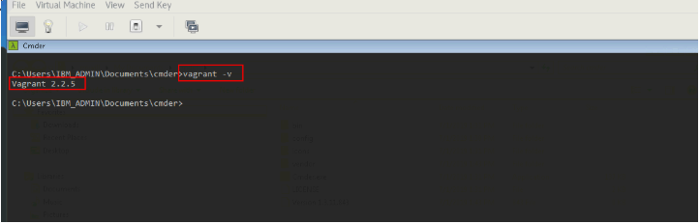
7) go to the following site and click on FIND BOXES
https://www.vagrantup.com/
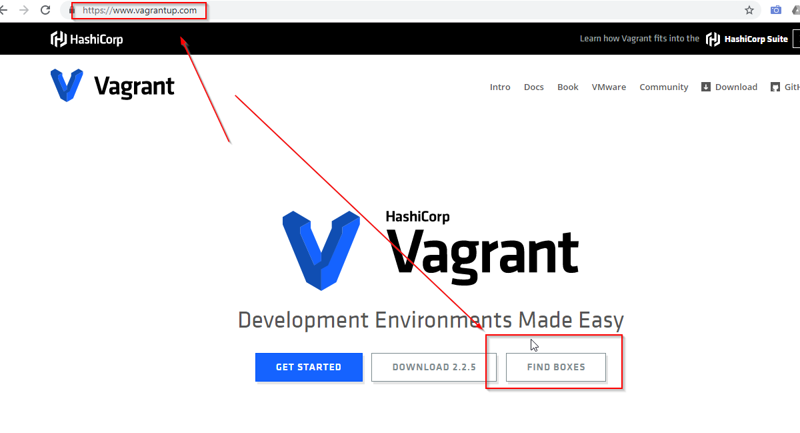
8) Search for Ansible and click on the first box.
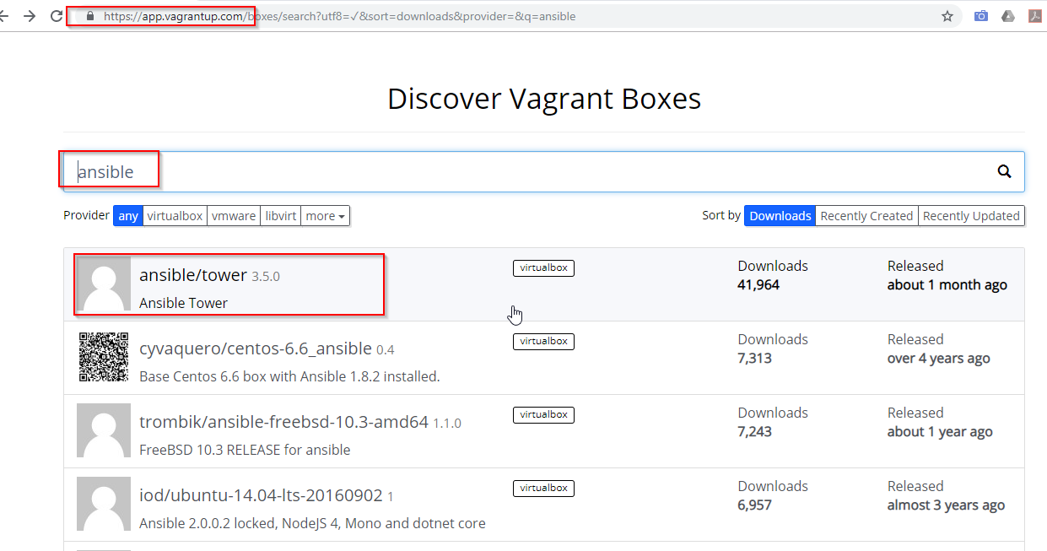

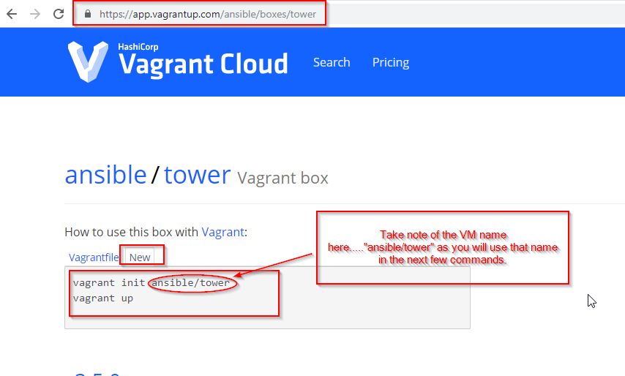
9) create a folder for that operating system and cd into that folder in the CMDER tool
10) once in that folder, run the following command to add this VM to your environment:
vagrant box add ansible/tower
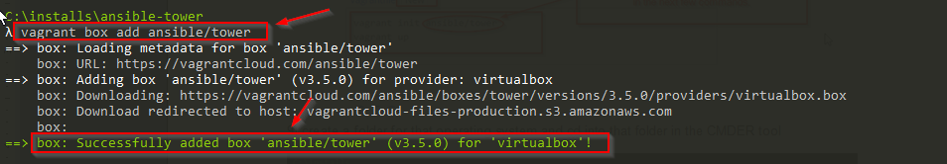
11) After adding the box, next you will need to Initialize it using the command below.
vagrant init ansible/tower
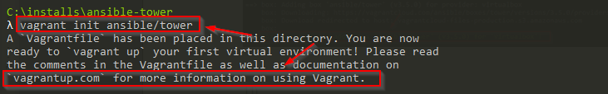

12) Now you should see a vagrant file in the c:\installs\ansible-tower that you defaulted to in step # 9 above:

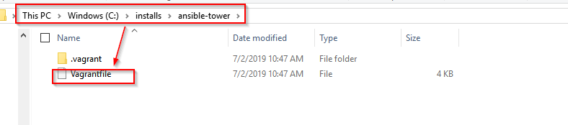

13) Now you are ready to power up the VM using the command below
vagrant up
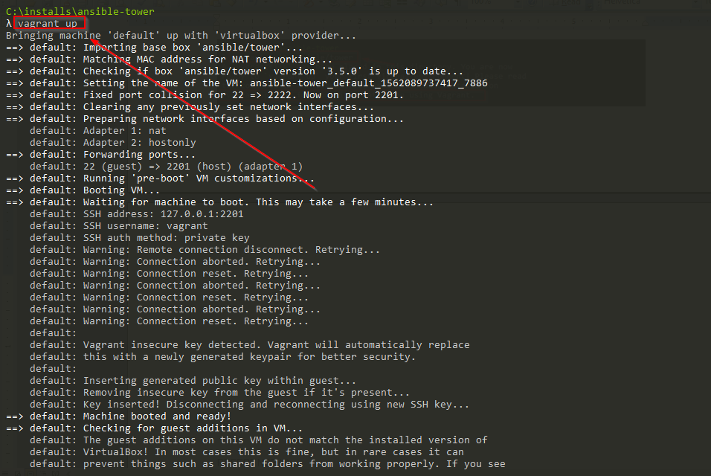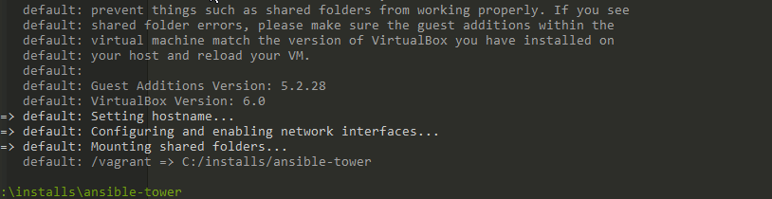

14) Now if you open up the VirtualBox Manager - you should see the VM machine running.

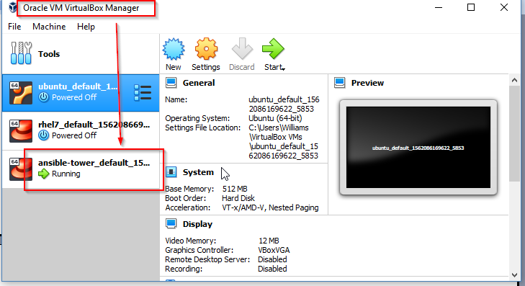

15) next run the command below to show the various information you will need for connecting to the VM. The 4 bottom arrows are pointing to information fields you will need in the next command for the ssh connection.
vagrant ssh-config
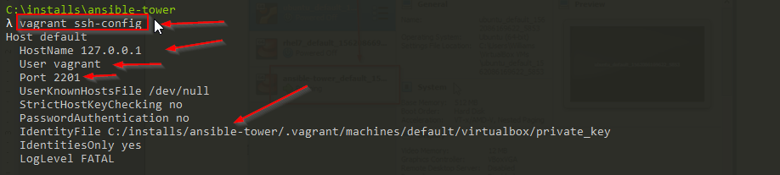

16) use the command below to connect to this VM. The password I used was "vagrant".
ssh vagrant@127.0.0.1 -p 2201 -i C:/installs/ansibletower/.vagrant/machines/default/virtualbox/private_key
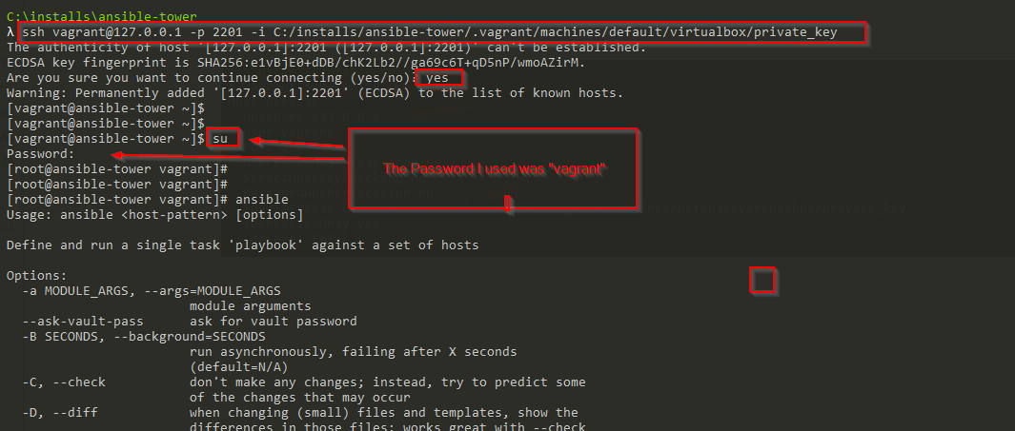
17) next run the "ansible --version" command to validate what version of ansible this server is currently running.
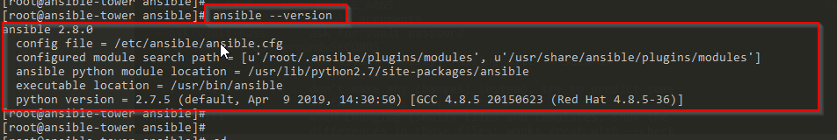
REFERENCE(s):
https://www.youtube.com/watch?v=mPBWWu7sZU4
https://www.jeffgeerling.com/blog/2018/testing-your-ansible-roles-molecule
https://w3-03.ibm.com/services/lighthouse/documents/82746
https://w3-connections.ibm.com/wikis/home?lang=en-us#!/wiki/IBM%20Watson%20Imaging%20Development%20team/page/Developer%20Machine%20Setup

